# **Title**

One2Many Speech Translator

# **Abstract**

This project aims to implement an enhancement for translator functions by outputting results of the translation on multiple smart devices. Unlike the original function that Google Translate offered, which is only able to receives input speech via a single device and display the result on the same device, the mobile application that developed in this project – One2Many Speech Translator able to receives input speech via a single device and display the result on multiple smart devices, such as smart phone, smart watch and smart glasses.

The system largely involves with University College of Technology Sarawak (UCTS) on the first few requirements and scenario. For example, during Muslim chanting, the “Host” can use the system, speak Arabic speech and translate it into Malay. The other smart devices, which act as “Client” or “Receiver” is responsible for showing the translated text. Also, the translator can support multiple input and output languages, not just Arabic to Malay.

In overall, One2Many Speech Translator will provide a more efficient manner in providing translated text to multiple devices and most importantly – bridging the gap between languages understanding.

# **Methodology**

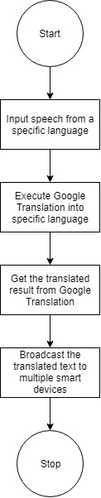

Figure 1: Flowchart of One2All Speech Translator

Figure 1 above describe the flow of process when using One2All Speech Translator. At first, one smartphone, which is the “Host” will responsible for inputting speech from a specific language. Then, the mobile application will translate the inputted speech into desired language, with the help of Google Translation API. After the translation process done, the result of translated text will then broadcast and display on multiple smart devices, which here refer as “Client”.

# **Technical Specification**

|  |  |
| --- | --- |
| **Type of Equipment** | **Details** |
| **Hardware** | **Smartphone — Minimum Specification**   * 3GB RAM and above * Minimum 128GB of internal memory card space   *At least two smartphones available and have the application installed |
| **Software** | **Smartphone — Minimum Specification**  At least Android 5.0 (Lolipop) and above |

YouTube link for the demonstration of mobile application: <https://www.youtube.com/watch?v=qJ0E5RqaUbk>